This is a 3 vs 3 battler. Each participant is randomly generated, with your team in the top row and the AI opponent’s on the bottom. Each unit has a starting ATK of 4 and 20 HP.
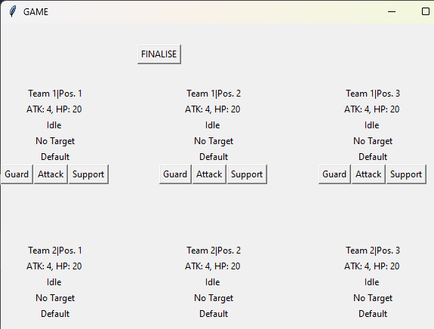
Game flow:
- Each unit can take one of three actions: Guard, Attack or Support.
  - Guard: Halve damage AND healing received for this turn.
  - Attack: Select a target on either side and calculate damage.
  - Support: Select a target on either side and change its state determined by attributes.
- Once you have selected an action for all available units on your side, click Finalize to automatically conduct these and the opponent’s actions in the following order:
  - Guard → Support → Attack
  - If multiple units perform the same action (e.g. Support), these will occur in a random order.
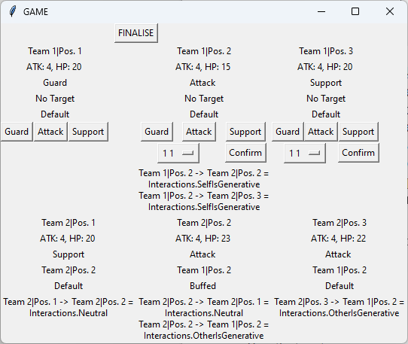
Units are listed in the form of
“Team # Position #”.
e.g. Here the targets are
“Team 1, Position 1”.
Each unit tracks their interactions with others (explained later). Use these to determine your next moves!

Attribute System:
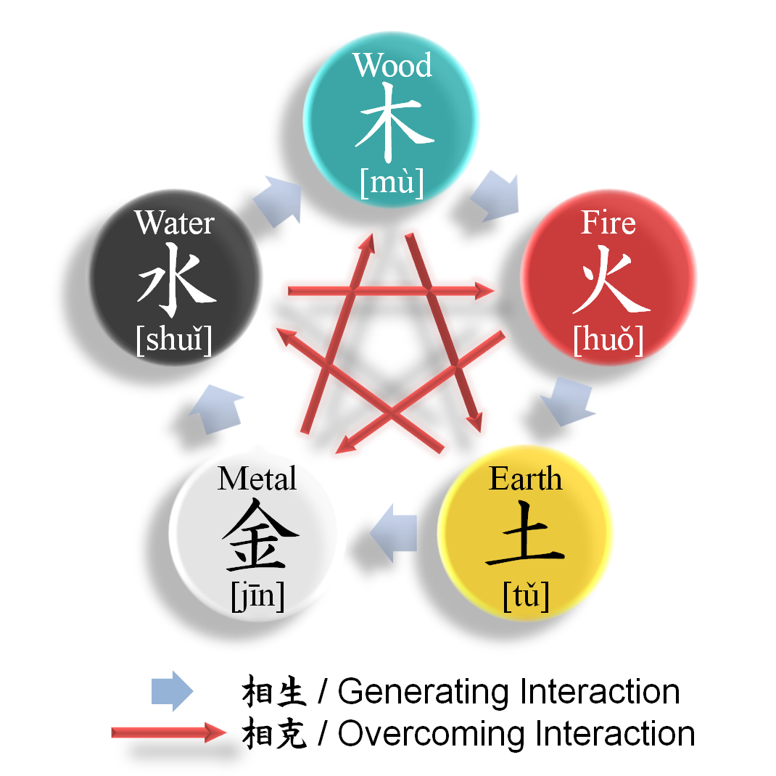
The attributes are based on the Wuxing (Five Phases/ Agents) of Chinese Philosophy. Based on their respective attributes, two units can have one of the following interactions:
- Neutral/ N (e.g. Wood acts on Wood)
- User is Generative/ UG (e.g. Wood acts on Fire)
- User is Destructive/ UD (e.g. Wood acts on Earth)
- Target is Generative/ TG (e.g. Wood acts on Water)
- Target is Destructive/ TD (e.g. Wood acts on Metal)

These interactions affect Attacks and Supports thusly:
 | Neutral | UG | UD | TG | TD
Attack | Damage is calculated normally | Target is healed by user's ATK value instead | Damage taken is doubled | User is healed by 50% of own ATK value | User takes damage equal to 50% of own ATK value
Support | Target’s state improves by one stage | Target’s state improves by two stages | Target’s state worsens by two stages | Both user and target's states improve by one stage | Target’s state improves by one state, user's worsens by one stage.

States:
There are five states which affect a unit thusly:
State | Effect
Default | None
Buffed | Attacks do 1 more damage
Super Buffed | Attacks do 2 more damage
Debuffed | Attacks do 1 less damage
Super Debuffed | Attacks do 2 less damage

